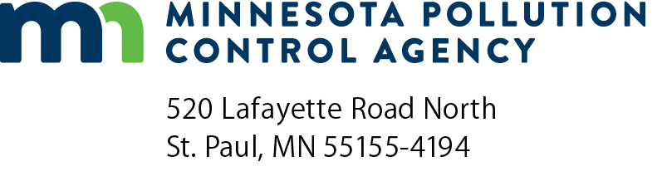 | Metro permit review  application checklist  Solid Waste Permit Program  Doc Type: Permit Application
Purpose: This checklist has been developed as a guide for permit application preparers and reviewers in order to assist with the submittal of a substantially complete permit application. Thoroughly review all applicable rules, statutes and guidance documents for further details and requirements. Minnesota Statutes can be found on the Minnesota Legislature’s Office of the Revisor of Statutes website at https://www.revisor.mn.gov/statutes/. All guidance documents can be found on the Minnesota Pollution Control Agency’s (MPCA) Solid Waste Publications webpage at https://www.pca.state.mn.us/waste/solid-waste-publications.
Many items listed below must be discussed in depth within the permit application submittal package. Be sure to include the most recently updated information, drawings and plans. Previously submitted documents cannot be referenced; all necessary documents must be included in this package. The permit application submittals should discuss all applicable MPCA guidance documents; include justification if the facility does not follow the guidance provided.
Instructions for permit application preparers: The following checklist must be completed and included with a permit application for all solid waste transfer facilities. In the table below, indicate in the far left column the name and page number(s) of the document where the specified rule requirement is addressed. If the rule requirement does not apply, please indicate with “n/a” for not applicable. The permit application will be determined to be incomplete if there are any blank spaces in this column.
Document  and  page number | Minn. R./Minn. Stat. citation | MPCA use only
 |  | Completeness review |  | Comments
 |  | Admin | Technical
§473.823 Subd. 3 (a)
Geographic area and population served. Highlighting environmental justice areas
§§ 473.149 Subd. 1 and 473.823 Subd. 3 (a) (b) (c)
Need for Facility
§§ 473.149 Subd. 1 and 473.823 Subd. 3 (a) (d)
Effect of facility on existing facilities
§§ 473.149 Subd. 1 and 473.823 Subd. 3 (a)
Effectiveness of Proposed Buffer Areas
§§ 473.149 Subd. 1 and 473.823 Subd. 3 (a) and 473.813 Subd. 1 & 2, 115A.471
Anticipated public costs and benefits of the facility
§§ 473.149 Subd. 1 and 473.823 Subd. 3 (a) and Minn. Stat. 473.151
Anticipated rates and charges
§§ 473.149 Subd. 1 and 473.823 Subd. 3 (a)
Manner of financing
§§ 473.149 Subd. 1 and 473.823 Subd. 3 (a) (d) (c)
Effect on Metro Plans, specifically recycling goals and landfill abatement
§§ 473.149 Subd. 1 and 473.823 Subd. 3 (a) (c)
Supply of waste
§§ 473.149 Subd. 1 and 473.823 Subd. 3 (a) and 473.813 Subd. 1 & 2, 115A.471
Solid waste supply contracts subject to 473.813
§§ 473.149 Subd. 1 and 473.823 Subd. 3 (a)
Anticipated markets for any product
§§ 473.149 Subd. 1 and 473.823 Subd. 3 (a)
Alternative means of disposal or energy production
§§ 473.149 Subd. 1 and 473.823 Subd. 3 (a) and Minn. Rules 7035.
Waste composition analysis
§§ 473.149 Subd. 1 and 473.823 Subd. 3 (a)
Additional information required by the commissioner – Environmental Justice criteria (Appendix B of Metro Policy Plan)

